

Indian institute of Information Technology, Lucknow

C.G. City Ahmamau, Lucknow – 226002

Marketing Management

Assignment

*Submitted by*

Dyovan Madhav

(MDB23024)

*Submitted to*

Prof Dr. Chhavi Taneja

MBA (Digital Business)

Semester 1

Term: 2023 – 2023

07 – 12 - 2023

**CASE STUDY ASSIGNMENT – MARKETING MANAGEMENT**

**1)** **Given the information in the case and your own understanding of the Indian marketplace, conduct a SWOT Analysis of Amazon Echo aka Alexa in India; especially in the context of Google Home as a key competitor.**

*Strengths:*

* Amazon echo have been more successful in integrating local languages and understanding Indian accents, which is really important, for offering the Indian customers the complete experience
* Alexa offers more localised music streaming services and prioritises on giving Indian specific news first than international like in google home
* Amazon echo devices are more available in the Indian retail market than google home
* It offers more skills, features and functionalities
* Better in terms of online shopping as it is integrated with amazon.com as well as other Amazon services
* Because of the early entry we can say that echo has been more dominant in the India smart speaker market segment.

*Weaknesses:*

* Amazon echo doesn’t offer an entry level speaker in terms of pricing, so it can be purchased only by those who can afford it, for many it can be considered as a premium luxury product.
* Because of it being tagged as a premium product it is not able to enter in to more homes. Many are purchasing the entry level products more which offers almost similar experiences.
* Customer service and other privacy related concerns have been addressed many times.
* Amazon have lesser local language compatibility while compared to google home.

*Opportunities:*

* Amazon have the opportunity to make an entry level product as well to capture the middle-class customers.
* They could introduce more Indian specific features, services and entertainment to make their product more attractive in the Indian market.
* Because of the latest trend of smart speaker amazon echo could have a boom in their sales.

*Threats:*

* Biggest threats they are facing now is the competition from cheaper speaker produces mainly google home. Their pricing is in such way that most of the middle range customers will go for google home without further thoughts
* Google home offers almost all the features in a more affordable price so a major part of the middle range market share goes to them.
* Invention of new features from competitor could also be a threat to them.

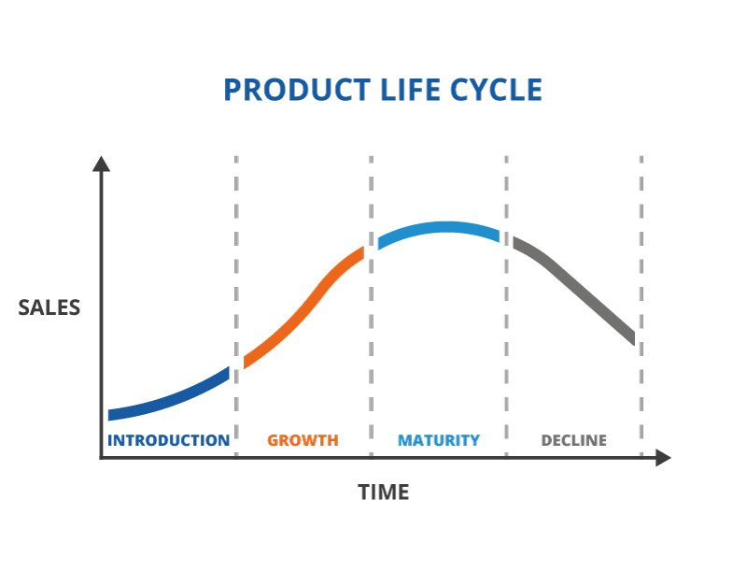**2)** **At what stage of the PLC are products such as Alexa and Google Home? Recommend the marketing strategies that marketers should adopt in these stages.**

Product life cycle are the series of stages a product face

From its launch to its withdrawal from the market. The

Stages are

* Introduction
* Growth
* Maturity
* Decline

In the case of **Alexa and Google home,** we can say that they are in the **growth stage** because the sales of smart speakers are still in the rise. The maturity level of smart speakers won’t be happening any time soon as the product is yet to reach millions of homes, mainly due to premium pricing and customers with not much knowledge regarding the usage of it. As the times goes by and the automation of house functionalities becomes more common then only it will reach the maturity stage.

**The marketing strategies they should adopt** in each stages varies, in the initial **Introduction stage** the marketers should be more focused on providing awareness to the potential customers, the advertisements they put out should be more focused on giving knowledge to them and making them understand the need for using it.

In the second stage that is the **Growth stage** marketers should focus more on enhancing and expanding the market share, mainly finding out the ways to achieve majority of the available market share. Adjustment of the pricing through trial and error and further improvement of the product should also be carried out.

Up next comes the **Maturity stage,** here they should find ways to be different from the competitors, they could diversify their products through introducing new features and services. Through this only they can remain in the market or else they will get pushed down from the other companies who do it better.

Then at last comes the **Decline stage** they should analyse the market and see if they can find any specific spots to take their product ,then they should try cost placement in such a way that they can try to squeeze in more last stage customers .they should find ways to maintain their loyal customers. If the sales is still in decline and affecting the finance in a negative way then they should try to phase out of the market gradually.